Smart Bar UIA1000
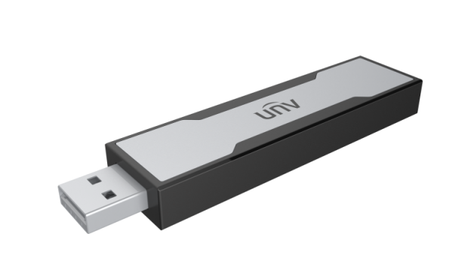

Key Features
- Support Ultra 265/H.265/H.264 video formats
- Face blacklist and whitelist function, can import 5 face blacklist/whitelist libraries.
- 4-channel real-time face comparison
- Real-time blacklist/whitelist face recognition alarm
- Monitoring management
- Tested in different scenes and proved scene-adaptiveness
- Small and light, low power, power saving

Specifications
Item | UIA1000
Video format | H.265, H.264
Function | Face recognition, real-time monitoring
Capacity | Up to 5 blacklist/whitelist libraries with up to 10000 face photos
USB interface | USB 3.0
Power supply | USB power supply  Power consumption ≤ 1.5 W
Working environment | Temperature: -10°C ~ + 55°C ( +14°F ~ +131°F )  Humidity: ≤ 90% RH (non-condensing)
Dimensions(W×D×H) | 89.3mm ×21.0mm ×9.8mm (3.52"×0.83"×0.39")
Weight | < 30g ( 0.07 lb )

Dimensions
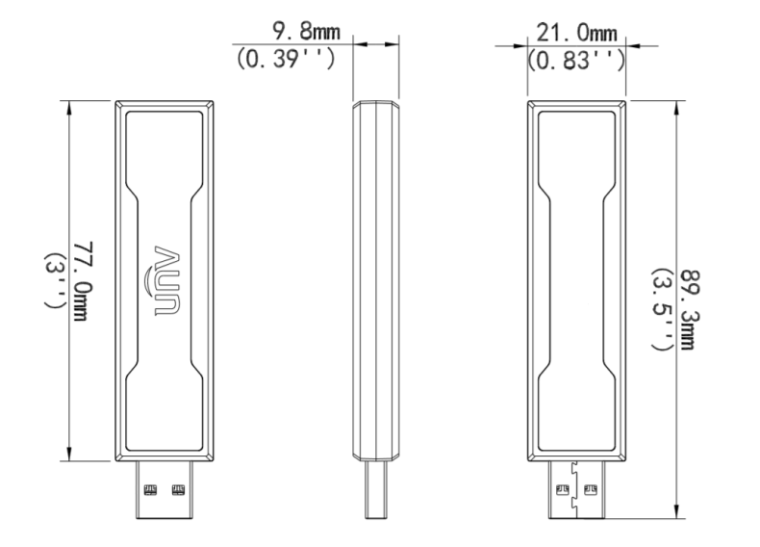

Zhejiang Uniview Technologies Co.,Ltd.
Building No.10, Wanlun Science Park, Jiangling Road 88, Binjiang District, Hangzhou, Zhejiang, China
Email: overseasbusiness@uniview.com;globalsupport@uniview.com
http://www.uniview.com
©2018 Zhejiang Uniview Technologies Co.,Ltd. All rights reserved.
*Product specifications and availability are subject to change without notice.

