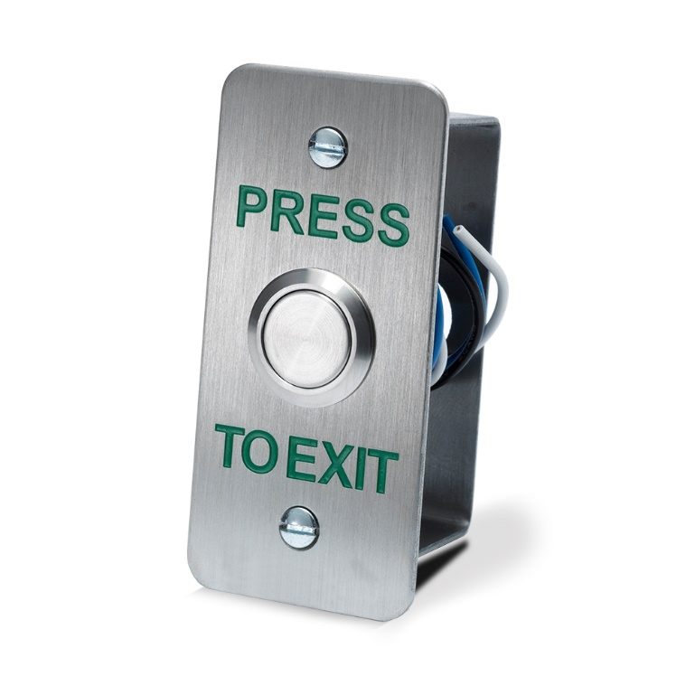
Press to Exit Button

Features:
- Brushed Stainless Steel
- 19mm Stainless Steel button
- Flush Mount
- Narrow Style

Dimensions
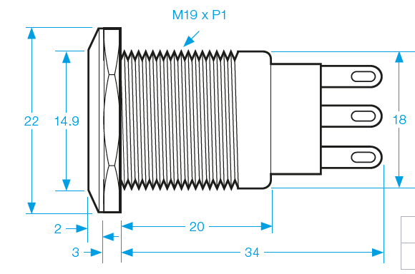
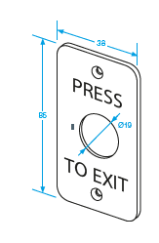
Specifications
- Max. rating 5A/125/250 Vac.
- Contact resistance: 50mΩ Max. (Initial).
- Operating travel: 2.7mm
- Operating life (Mechanical): Over 100,000 times.
- Cables included.

