TA1060 60W Mixer Amplifier
The Mixer Amplifier Series is the range of mixer amplifiers that can handle 4 microphone inputs and 2 auxiliary inputs, making this series suitable for small and medium scale public address applications, such as mosque, office, restaurants or pubs, fitness clubs, auditoriums, retail stores, warehouses, and factories. It comes with individual input gain controls with a master volume control. Bass and Treble controls are provided for the user’s equalisation preference. It is integrated with voice muting function for Mic 1, thus giving it the highest priority to override other sources during TMA-1060 emergency situation. Able to operate off mains or an external battery, the Mixer Amplifier Series is a viable solution for any mobile application from a family day sports event to a large-scale garden party.
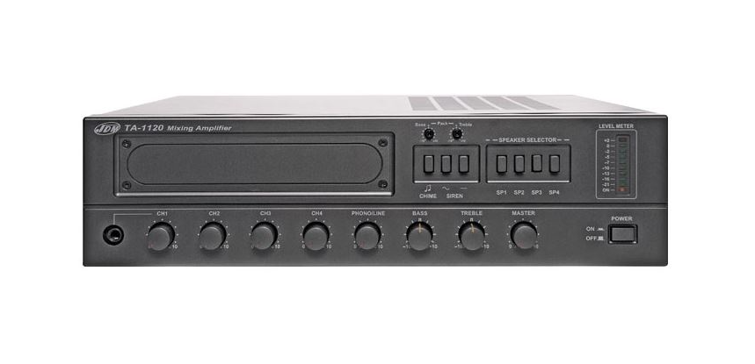
Key Features
- 4 microphone inputs with user selectable phantom power.
- Individual gain control on all 4 microphone inputs.
- Short circuit and over current protection with resettable fuse cut-off. In the event of a short circuit, just rectify the line and reset the amplifier and normal operation will resume.
- Voice activated muting function enables MIC 1 to override all the inputs.
- Bass and Treble Master tone control for equalization and audio tuning. Dual mode power supple of either AC mains or DC battery supply

