RJ45 Boots – Packs of 100
RJ45 boots provide strain relief and latch protection on RJ45 cables.
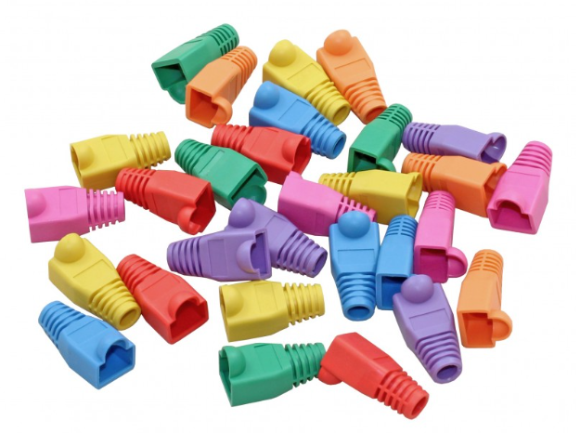
These boots are suitable for use with Cat5e and Cat6 cable.
Colours:
- Red
- Yellow
- Orange
- Blue
- Green
- White
- Grey
- Black
- Violet
Features:
- Multi-coloured for labelling
  - The cat6 strain relief boots come in variety of colours, allowing you to colour-code cables to coordinate your ethernet setup and providing you a super easy solution for cable management.

- Universal Compatibility
  - Compatible with all standard RJ45 8P8C modular plugs. The diameter at the end of the cap is 6mm and the RJ45 sleeve can be used with Cat6/Cat5e/Cat5 LAN cables.

- Stable & professional connection
  - The RJ-45 caps can protect your ethernet cable ends from dust and oxidation, preventing poor conductivity and extending your plug’s lifetime.

- Reliable Quality
  - RJ45 plug coves are made of reliable rubber soft plastic material, so it's flexible and easy to install and will hold onto the connector very snugly. Please remember to put the cover on the cable BEFORE doing the RJ45 crimp.

